EXP NO: 3A ROLL NO: 231901048

DATE: 3.8.24 NAME: P.SHAMRUDHA VARSHINI

STUDY OF DIFFERENT TYPES OF NETWORK CABLES

Aim:

Study of different types of Network cables.

a) Understand different types of network cable.

Different type of cables used in networking are:

1. Unshielded Twisted Pair (UTP) Cable
2. Shielded Twisted Pair (STP) Cable
3. Coaxial Cable
4. Fibre Optic Cable

|  |  |  |  |  |  |
| --- | --- | --- | --- | --- | --- |
| Cable type | Category | Maximum  Data  Transmission | Advantages/ Disadvantages | Application/Us  e | Image |
| UTP | Category 3 | 10 bps | Advantages  ∙ Cheaper in cost ∙  Easy to install as they have a  smaller overall diameter.  Disadvantages  ∙ More prone to  (EMI)  Electromagne tic interference and noise | 10Base-T Ethernet  Fast Ethernet,  Gigabit Ethernet  Fast Ethernet,  Gigabit Ethernet |  |
| Category 5 | Up to 100  Mbps |
| Category 5e | 1Gbps |

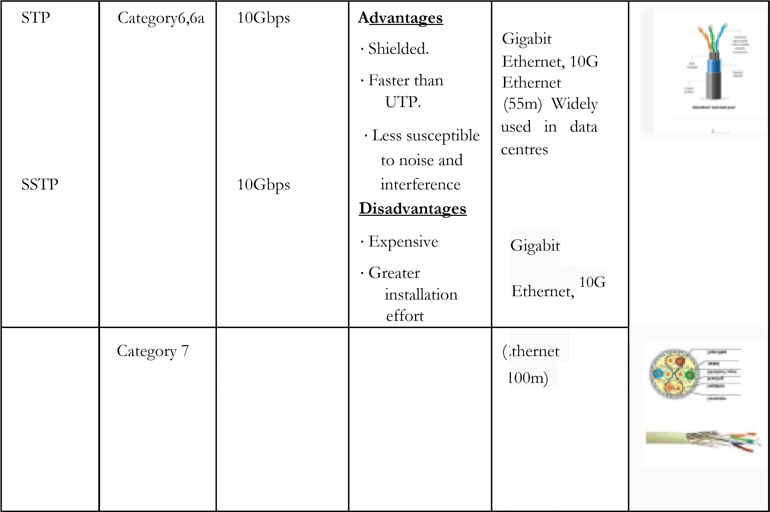

14 | P a g e 2 0 2 4 - 2 5

# CS19541-COMPUTER NETWORKS-LAB MANUAL

|  |  |  |  |  |  |
| --- | --- | --- | --- | --- | --- |
| Coaxial cable | RG-6  RG-59  RG-11 | 10-100Mbps | ∙ High bandwidth  ∙ Immune to interference  ∙ Low loss bandwidth  ∙ Versatile ∙  Disadvantages ∙  Limited distance ∙  Cost  ∙ Size is bulky | Speed of signal is  500m  Television network High speed internet connections |  |
| fibre optics cable | Single mode  Multi mode | 100Gbps | Advantages  ∙ High speed  ∙ High bandwidth  ∙ High security ∙ Long distance  Disadvantages  ∙ Expensive  ∙ Requires skilled | ∙ Maximum distance of fibre optics cable is around 100meters |  |
|  |  |  | installers |  |  |

15 | P a g e 2 0 2 4 - 2 5

# CS19541-COMPUTER NETWORKS-LAB MANUAL

b) Make Your Own Ethernet Cross-Over Cable/ Straight cable

Tools and parts needed:

∙ Ethernet cabling. CAT5e is certified for gigabit support, but CAT5 cabling works as well, just over shorter distances.

∙ A crimping tool. This is an all-in-one networking tool shaped to push down the pins in the plug and strip and cut the shielding off the cables.

∙ Two RJ45 plugs.

∙ Optional two plug shields.

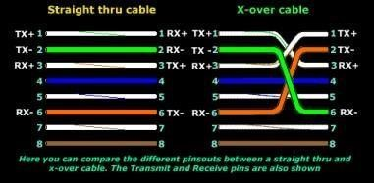

Difference between crossover cable and straight cable

Take a print out the diagram below or have it handy as a reference

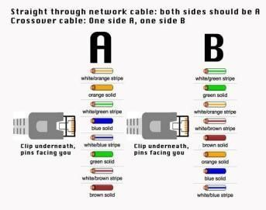16 | P a g e 2 0 2 4 - 2 5

# CS19541-COMPUTER NETWORKS-LAB MANUAL

Step 1: To start construction of the device, begin by threading shields onto the cable.

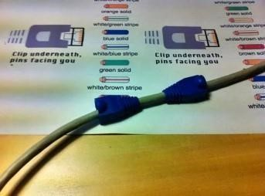

Step 2: Next, strip approximately 1.5 cm of cable shielding from both ends. The crimping tool has a round area to complete this task.

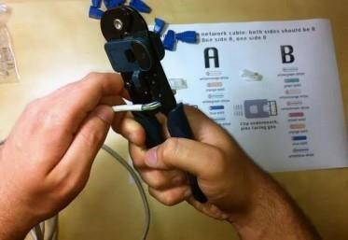17 | P a g e 2 0 2 4

- 2 5

# CS19541-COMPUTER NETWORKS-LAB MANUAL

Step 3: After, you will need to untangle the wires; there should be four “twisted pairs.” Referencing back to the sheet, arrange them from top to bottom. One end should be in arrangement A and the other in B.

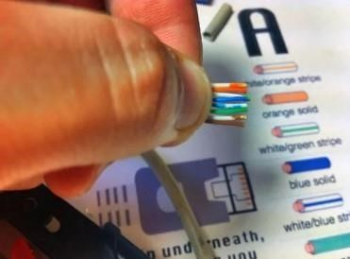

Step 4: Once the order is correct, bunch them together in a line, and if there are any that stick out farther than others, snip them back to create an even level. The difficult aspect is placing these into the RJ45 plug without messing up the order. To do so, hold the plug with the clip side facing away from you and have the gold pins facing toward you, as shown.

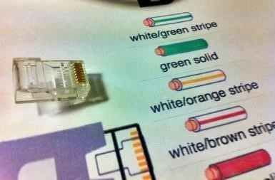18 | P a g e 2 0 2 4 - 2 5

# CS19541-COMPUTER NETWORKS-LAB MANUAL

Step 5: Next, push the cable right in. The notch at the end of the plug needs to be just over the cable shielding, and if it isn’t, that means that you stripped off too much shielding. Simply snip the cables back a little more.

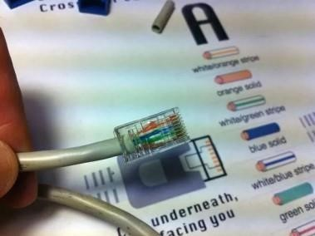Step 6: After the wires are securely sitting inside the plug, insert it into the crimping tool and push down.

It should be shaped correctly, but pushing too hard can crack the fragile plastic plug.

Step 7: Lastly, repeat for the other end using diagram B (to make a crossover cables)/ using diagram A (to make a straight through cable)

To test it, plug it in and attempt to connect two devices directly.

## Student observation:-

1. What is the difference between cross cable and straight cable?
2. Which type of cable is used to connect two PC?(straight/Cross cable)
3. Which type cable is used to connect a router/switch to your PC?

(straight/Cross cable)

1. Find out the category of twisted pair cable used in your la to connect the PC to the network socket.
2. Write down your understanding, challenges faced and output received while making a twisted pair cross/straight cable. Difference between Cross Cable and Straight Cable:
3. Straight Cable: Wires are arranged in the same order on both ends. Used for connecting different types of devices (e.g., PC to switch).
4. Cross Cable: Wires are crossed at one end (Tx and Rx pairs are swapped). Used for connecting similar devices (e.g., PC to PC).

■ Cable to Connect Two PCs: Cross cable.

■ Cable to Connect Router/Switch to PC: Straight cable.

■ Category of Twisted Pair Cable: Likely Cat5e or Cat6 depending on the network setup.

■ Understanding, Challenges, and Output:

1. Understanding: Creating a twisted pair cable involves arranging wires according to T568A or T568B standards.
2. Challenges: Ensuring the correct order of wires, proper crimping, and avoiding misalignment of the pairs.
3. Output: Successfully created a cable that established a proper connection between devices.

CSE(CYBERSECURITY)

19 | P a g e 2 0 2 4 - 2 5